k

**Lab # 05**

**OBJECT**

***Step by step Installation of CentOS and managing services in CentOS***

**LAB TASK:**

# Step 1: Prepare a host and install CentOS 8 VM in VirtualBox

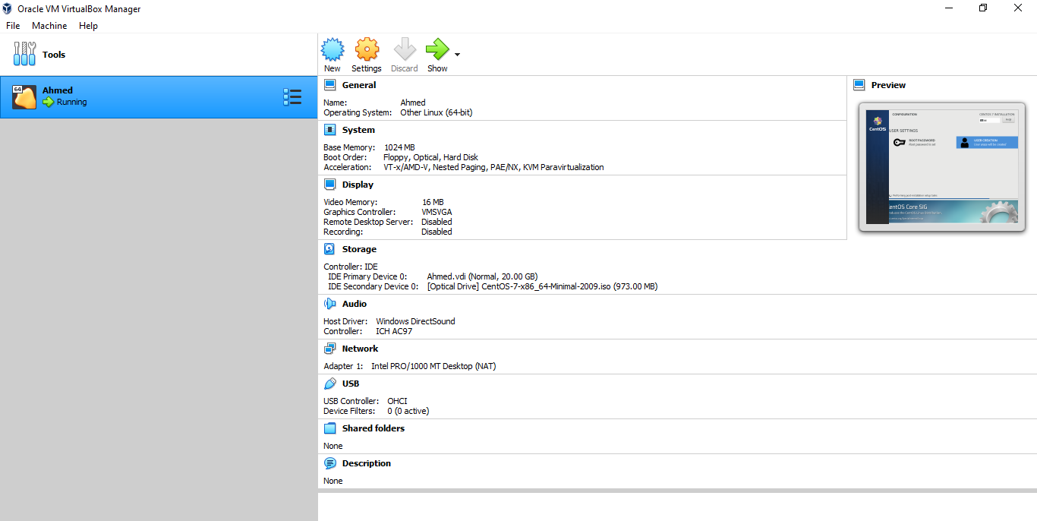

# Step 2: Create a new VM in VirtualBox with your name

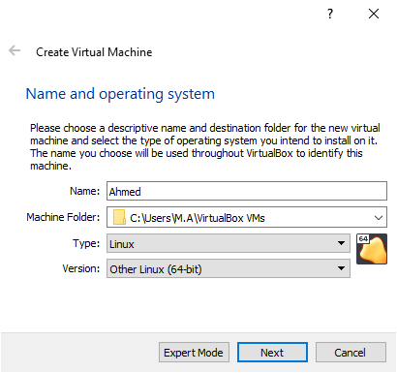

Step 3: **Allocate 1024MB RAM to your VM**

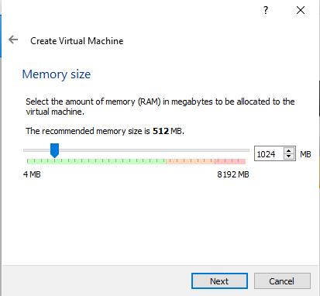

# Step 4: Add Virtual Hard Disk to the new VM in VirtualBox

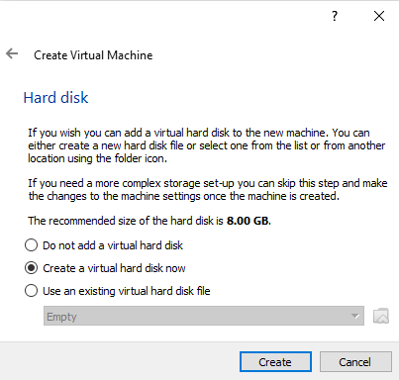

# Step 5: Choose the type of file that you would use for the VHD

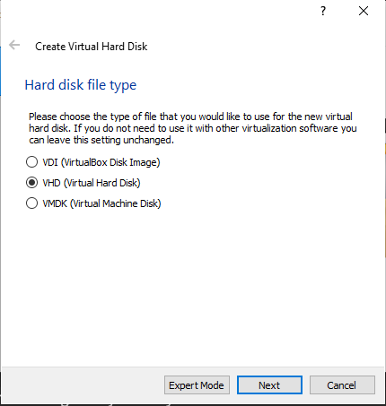

# Step 6: Select the Storage for your Physical Hard Disk

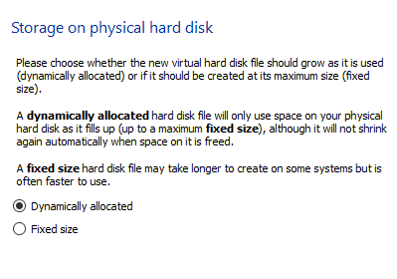

# Step 7: Choose the file location and set the disk size to 20 GB

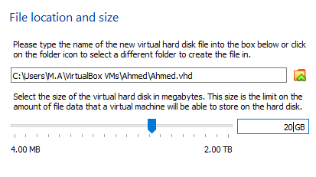

# Step 8: Prepare a host and install CentOS 8 VM in VirtualBox

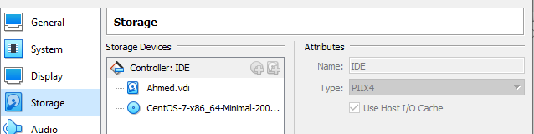

# Step 9: Go to settings in VirtualBox, select storage and select the ISO image

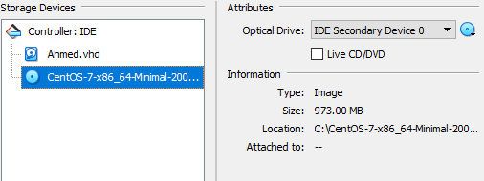

# Step 10: Go to settings in VirtualBox, select the Bridge Adapter

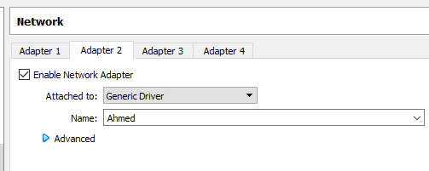

# Step 11: Go to Systems in VirtualBox, select the dual processor

